Chapter 5
- Define motion: a change in distance relative to a reference point
reference point: an object used to determine if another object is in motion
speed: the distance an object travels in a given amount of time
- What is the difference between speed and velocity?
  - Speed is distance traveled in a given amount of time and velocity is the speed of an object in a certain direction
- Describe the difference between velocity and acceleration. (page 120-121)
  - Velocity is speed in a certain direction and acceleration is any change in motion (speed up, slow down, change direction)
- What is a force? (page 124 and notes)
  - A force is a push or a pull that could result in the change in motion of an object
- Define: balanced force – an unmoving object with a net force of zero
Newtons
unbalanced force – a moving object with a net force of greater than zero Newtons
- Define friction. (page 128)
  - An unbalanced force that slows down moving objects
- List 2 ways to increase friction. (page 132-133)
  - Rougher surfaces
  - Increase applied force
- List 2 ways to decrease friction. (page 132-133)
  - Smoother, lubricated surfaces
  - Rolling kinetic friction instead of sliding friction
- Define gravity. (page 134)
  - the force that attracts a body toward the center of the earth, or toward any other physical body having mass
- How is gravitational force increased? (p. 136-137)
  - Increase mass and decrease distance
- How is gravitational force decreased? (p. 136-137)
  - Increase distance and decrease mass
- What is the difference between mass and weight? (page 138)
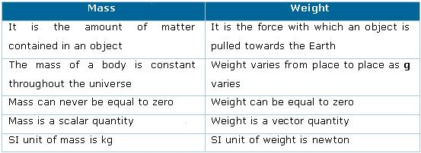

Chapter 6
- Define inertia. (page 160)
  - the resistance of any physical object to any change in its state of motion, including changes to its speed and direction.
- Explain the relationship between force, mass, and acceleration. (page 161)
  - The force it takes to move (or accelerate) an object varies – depending on the mass of the object. Example: less force is required to move (or accelerate) an empty shopping cart than a cart filled with grocery items
- Describe action force: the force applied to an object or person
reaction force: the equal and opposite force occurring after an action force is applied

Chapter 8
- What is work?
  - Work occurs force and motion occur in the same direction
- What is a machine?
  - A machine is a device that makes work easier
18. Describe the six simple machines:
Lever: A simple machine made with a bar that pivots (move) around a fixed point called a fulcrum

Pulley: A simple machine made with a rope or chain wrapped around a grooved wheel; A pulley changes the direction of the force OR the size of the force

Wheel and Axle: A wheel and axle consists of 2 circular objects of different sizes. Example: faucet, pencil sharpener, door knob

Inclined Plane: A simple machine with no moving parts. It is simply a straight slanted surface. ( Ex. a ramp.)

Wedge: A modification of an inclined plane that moves. It is made of two inclined planes put together.

Screw: An inclined plane that wraps around a cylinder.

Chapter 9
- Define energy.
  - The ability to do work
- Define kinetic energy. (page 241)
  - The energy of motion
- Define potential energy. (page 242)
  - Stored energy; energy due to an object’s position or height
22. Describe the seven forms of energy. (pages 244 – 246)
- Thermal energy – energy of the motion of atoms/molecules in a substance
- Chemical energy – the energy stored in the bonds of compounds of matter (ex.: gasoline, food, batteries)
- Electrical energy – the energy of the moving electrons
- Sound energy – energy of vibrating molecules in a solid, liquid, or gas
- Light energy – reflected or emitted from objects in the form of electrical and magnetic waves that can travel through space.
- Nuclear energy – energy from the splitting or fusing of nuclei
- Mechanical energy – potential + kinetic energy
Chapter 9 (continued)
23. Draw and label the energy conversion that occurs on a roller coaster. (page 254)
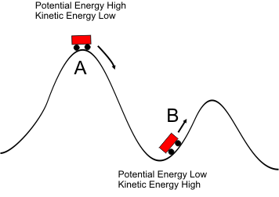Also, thermal energy is used.
24. State the law of conservation of energy.
Energy cannot be created or destroyed – it changes forms

Chapter 10
25. Define heat.
The transfer of thermal energy from high temperature to lower temperatures until equilibrium is reached
26. What is conduction?
Heat transferred through direct contact

27. What is convection?
heat transfer by differences in density of a fluid such as air or water (gases and liquids)
28. What is radiation?
Heat transferred through empty space

Chapter 17
29. What is an insulator?
A material that does not allow thermal or electrical energy to flow easily (glass, rubber, wood)
30. What is a conductor?
A material that allows thermal/electrical energy to flow easily (metals, water)
31. What is a series circuit?
A single pathway for electrical energy to flow; if a break in the circuit occurs, all energy stops flowing
32. What is a parallel circuit?
A pathway for electrical energy with multiple routes; if a break in the circuit occurs, charges have alternate routes to flow
33. What are the three parts of an electric circuit?
Load, energy source, wires

Chapter 18
34. What is a magnet?
a piece of iron (or an ore, alloy, or other material) that has its aligned atoms (domains) so ordered that the material exhibits properties of magnetism
35. Define magnetic force.
attraction or repulsion that arises between poles of a magnet due to their atomic alignment (domains)
36. How can you make an electromagnet?
Wrap wire around an iron bar and attach ends of wire to a battery – the iron core becomes magnetic; the stronger the battery and/or the more coils of wire, the stronger the electromagnet
37. Draw a magnet with north and south poles and draw the magnetic field lines.
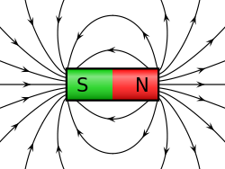

Chapter 20
38. What do waves transfer?
Waves transfer energy
39. What is the difference between mechanical and electromagnetic waves?
Mechanical waves require a medium and electromagnetic waves can travel through empty space
40. Draw and label a transverse wave.
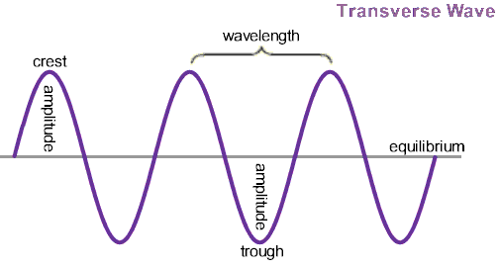
41. Draw and label a longitudinal wave.
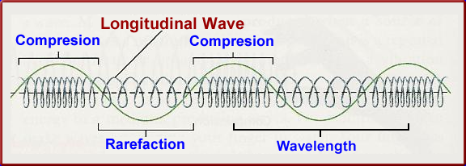
42. List and define the 4 properties that all waves have.
1) AMPLITUDE – the distance from the rest position to the crest or trough of a wave; relates to height of a wave and volume of a sound wave
2) FREQUENCY - the number of crests of a wave that move past a given point in a given unit of time. The most common unit offrequency is the hertz (Hz)
3) WAVELENGTH – the distance between any 2 corresponding points on a wave (ex.: two crests or two rarefactions)
4) SPEED - the distance traveled by a given point on the wave (such as a crest) in a given interval of time

43. What is reflection?
change in direction of waves when they bounce off a barrier;
44. What is refraction?
change in the direction of waves as they pass from one medium to another;
45. What are the 2 kinds of interference?
Constructive interference and Destructive interference
Chapter 21
46. Is sound a mechanical or electromagnetic wave?
Sound is a mechanical wave because it has to travel through a medium
47. What is sound?
Sound is a a wave of compression and rarefaction, by which sound is vibrates in a medium such as air.

48. What is the speed of sound?
340.29 m / s

Chapter 22
49. Draw and label the electromagnetic spectrum.
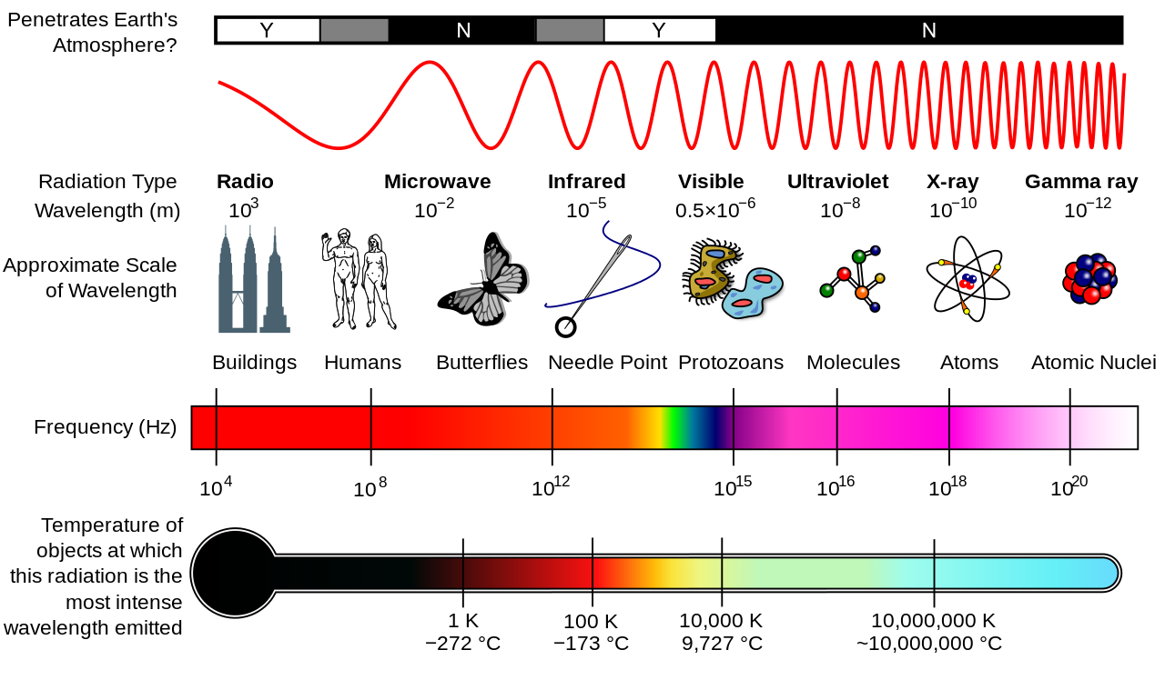

50. What colors are included in visible light?
Red, Orange, Yellow, Green, Blue, Indigo, Violet

